SaveTheGlam Meeting 31.03.21

Registered on Zoom [∆ indicates attended]

18 Sean Fitzsimons∆; Steve Thompson∆; Roger Wagner∆; Ron Appleby∆; Jeremy Fitzpatrick∆;
Jonathan Leslie∆; Neil Pettigrew∆; Jacqueline George; Deborah Daintith∆;
Joe Benedict (Cronx Brewery)∆; Dave Willmer∆; Rhiannon Hughes∆; Brendan O’Connor;
Ian Woodard∆; Rachel Pickering; John Lennon; Shahzad Kalim∆;
Richard Mullins∆; Tony Skrzypczyk∆; Matt Plumley∆; Cathy & Bob∆; Mark Russell∆;
Jonathan Leslie∆; Ken Brewster∆; [if I missed anyone please contact]

Apologies

Thomas Boeke; Rhiannon Morgan;

MINUTES for “Save the Glamorgan” Meeting held on Wednesday 31st March 2021 at 7:30pm

1. Approval of minutes of meeting held on 27th January 2021 √ approved

2. Updates on Action Points from last meeting

2.1 Neel Singh & Joe Benedict to agree an approach and to then write to the owners offering a price for the Glamorgan’s freehold. RA to send copy of all dialogue between him and the owners to Neel to assist in this - RA/NS/JB
RA duly reviewed all of his previous dialogue with the owners - sent as a Word doc to NS & JB on 27 Jan. JB sent RA the formal offer on 3rd Feb, for sending onto the owners with covering comments from the campaign. ACTION POINT CLOSED.

2.2 Ron Appleby to contact owners to forward the Cronx/Dorking Offer and to confirm that the campaign fully supports their offer – RA reported that Cronx/Dorking offer was sent to owners on 10th March. Reply received from Amar Mehli that day stating that „they have had several offers between £2.1m to £2.3m which they have not pursued as they still believe in their original plan, but if our group can match the best current offer of £2.3m then they would consider a sale and maybe walk away from this opportunity”. ACTION POINT CLOSED.
2.3 Sean Fitzsimons to investigate lack of marketing/restoration/valuation for planning process with Council – SF reported that no council visit had been made to check on the state of the building – he will investigate a possible breach of planning and accommodation rules by the owners, using The View public house as an exemplar of the owners’ behaviour, as well as the condition of The Glamorgan building that the owners have let it deteriorate into.
SF to also contact the Private Rent Team about the conditions that the squatters must be living in.
Steve Thompson reminds of owner’s record in The Glamorgan’s blocked drains/smashed sinks/hazardous access/neighbourhood disturbances/owner-enabled squatters.

2.4 Rodger Molyneux to scrutinise the pub’s financial figures included in the planning application and comment on their accuracy – RA Rodger Molyneux’s Financial Viability Scrutiny was sent to RA on 17th March, and is as follows, with Rodger’s comments in red:-

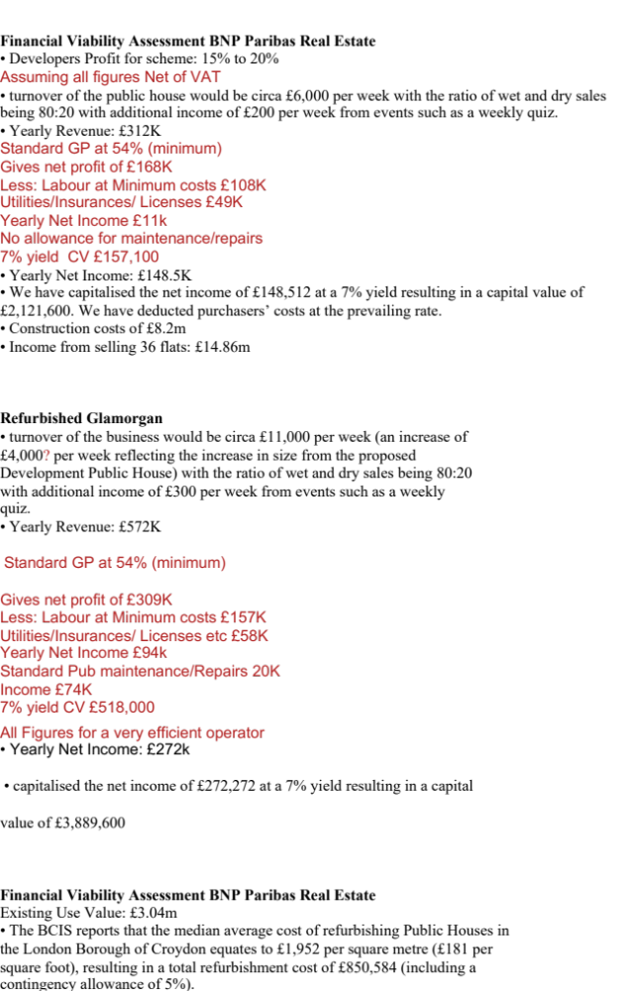
Landowner premium
• value of £3,494,868 as our viability benchmark
Residential Land Value: The difference between the total development
value and total costs equates to the residual land value (“RLV”).
RVL of between -£749k and -£1.5m, means no affordable housing
without subsidy from Mayor of London

Issues highlighted by SEAN that need reviewing/assessing
• Are the Financial Viability Assessment BNP Paribas Real Estate figures
correct?
• Are the figures for original and new pub income and expenditure, and
net revenue correct? No
• Is 800K correct to refurbish current pub? Roughly, depends on state of building.
• Can we challenge the Existing Use Value and Landlord Premium?
I don't know what they are based on, so difficult

Further information supplied by Rodger Molyneux on 6th March :

Glamorgan ltd, has just made its (very late) annual return and avoided being struck off.
Assets £1,558,872
Creditors £1,736,223
Net liabilities £177,351 (debt)
Loss on year £33,927

Late filing penalties will be several thousand on top. ACTION POINT CLOSED.

2.5 SF to explain implications of reply received from Croydon Planning Department (21.02.21) concerning the owner’s proposal to provide a ‘bar’ at the ground floor level – SF reports that the bar in the owner’s published plan is non-viable under the Croydon Plan, which is probably why the owner has withdrawn the application. ACTION POINT CLOSED.

2.6 Impact of fund announced in 2021 budget for Councils to draw upon to fund purchases of properties protected as AOCs (under Localism Act of 2011) - SF reports Croydon Council is reluctant in its present financial circumstances, nevertheless …

Community Ownership Fund
Announced in today’s Budget (3/3/21), this £150 million Fund will help communities across the UK buy local assets that are at risk of being lost. From June 2021, community groups will be able to bid for up to £250,000 matched funding (i.e. matching funds which the groups have raised) to purchase local assets to run as community-owned businesses.
ACTION POINT CLOSED.

3. Action Plan for the Campaign : next steps
- Beermat Broadcast 17 May
- Continue to explore ‘The Glamorgan’ Viability as Pub

SF reported that the concerns raised by Croydon planning office/Mayor of London may have forced Amar to withdraw the application - not viable under Croydon Plan because does not replicate facilities of original pub
Joe Benedict backs community pressure, to be publicised - SF suggests press release/pub garden protest on 12 April? Or on 17 May?
Roger Wagner reminds we have a campaign song which could be used again at events
Rhiannon Hughes offers help with visuals – target print beermats 500 for £100?
Richard Mullins suggests the owner’s ‘architect visualisation’ of The Glamorgan in a housing context is powerful propaganda against the owner’s plan - invite pdf beermat contributions by 13 Apr
Ken Brewster believes beermats are cheap - target ?lunchtime/afternoon?17 May full pub re-opening – members to go on to a designated pub afterwards

NOTE : On 2nd April RW sent email to all campaign members inviting them to submit designs for beermats to be used to raise awareness of Glamorgan’s situation

- Any other business - none

5. Date of Next Meeting Thursday 13th May 2021 at 7:30pm

