MINUTES for Annual General Meeting to be held on Wednesday 28th October 2020 at 7pm

Present (15 - quorate):
Ron Appleby; Roger Wagner; Steve Thompson; Patricia Hay-Justice (Apologies left @ 7:30); Dave Lands; Jerry Fitzpatrick; Neil Pettigrew; Toby Martlew (Oval Primary School, Principal); Ian Woodard; Jason Hinton; Thomas Boeke; Jonathan Leslie; Sarah Jones Croydon Central MP; Sean Fitzsimons; Tomas Howard-Jones

Apologies:
Pravina Ellis; Rachel Pickering; Rhiannon Morgan; Jacqueline George; Rodger Molyneux; Matt Plumley; Miriam Heyburn; Joe Benedict; representative of Dorking Brewery

- Approval of minutes of meeting held on 15th January 2020
Agreed
- Election of new Management Committee
2.1 Election of Chairperson Ron Appleby - agreed unanimously
2.2 Election of Secretary Roger Wagner - agreed unanimously
2.3 Election of Treasurer Steve Thompson - agreed unanimously
2.4 Election of Campaign Co-ordinator Sean Fitzsimons - agreed unanimously
- Presentation of Chairperson’s report on Campaign Group’s activities over past 12 months

Chairperson Report on Campaign Group activities Oct 2019 to Oct 2020
23 OCT 2019
Second AGM for the Campaign held, various actions discussed and plans made for meetings with Croydon Council.
2 DEC 2019
Christmas social meeting held at The Oval Tavern.
14 JAN 2020
Meeting held between Campaign Officers and Cronx Brewery to discuss their Business Plan for running The Glamorgan as a Community pub. Subsequent discussions to be held between Campaign Officers and Croydon Council officials.
15 JAN 2020
Campaign meeting held, various actions discussed.
6-8 FEB 2020
Campaign banner displayed at CAMRA’s South Norwood Beer Festival. Campaign leaflets also distributed at this festival.
9 APRIL 2020
Campaign meeting scheduled, but was cancelled due to Coronavirus pandemic.
APRIL – OCTOBER 2020
Campaign officers unable to undertake any meetings with Croydon Council officials due to Coronavirus pandemic.
Early OCT 2019
New Planning application submitted by Amar Dhatt for demolition of The Glamorgan and redevelopment of the site into 36 flats/maisonettes plus a small ground floor bar.

RON APPLEBY
Save The Glamorgan Campaign Group Chairperson

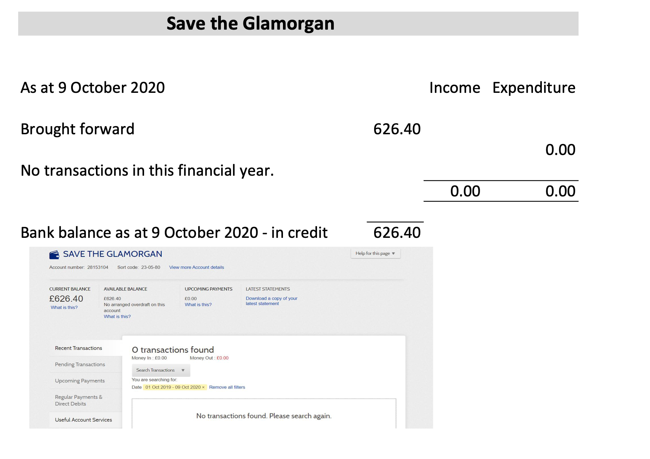
- Presentation of Treasurer’s report on Campaign Group’s Finances by Steve Thompson

- Submission by Pub Owners of a Planning Application to demolish The Glamorgan and develop the site
Discussion of SaveTheGlam Objections:
Jerry reminded, Croydon’s ACV remains as block to the owner’s Planning Application. Timeline since 2018 (renewal required after 5 yrs of an ACV) - refresher of SaveTheGlam’s concern needed through Sean.

Thomas Boeke reports so far there are 5 objections & only 2 supports recorded. Members need to register their objection by 4 Nov 2020. Dave Lands has a specimen objection letter ‘Save Our Pub’ which we can individualise.

New member Toby Martlew, Principal of Oval Primary School, expressed concern about the neglect of the property attracting ‘unsavoury actions by individuals’ to the vicinity of the school. Sarah Jones, Croydon Central MP, is willing to help draw the attention of the authorities.

In view of the departure of Patricia Hay-Justice to another virtual meeting, Sean Fitzsimons proposed the quorum requirement for the remainder of the meeting be suspended - agreed unanimously.

Sean Fitzsimons has an agenda of ‘Ideas for Opposing’ the planning application document. To be sent out to members to guide the registration of objections in the week before the 4 November. Council Determination deadline is 4 Jan 2021; Amplifications of Objections can be sent up that date. The Plan envisages a 10/11 storey tower, 36 flats and a very small ‘Bar’. No ‘Affordable Accommodation’ is offered in the plan, since in the view of the owner, it would make the development ‘non-viable’.

The tower development has a Larger Footprint than the current building. The planned ‘Garden’ is a third of the area of the current pub facility, and will not be available to bar customers, since it is designated for residents. Objectors may raise a Challenge to the owner’s claim to have marketed the pub after purchase. The owner has refused to allow a survey to establish the current valuation following neglect, to investors identified by SaveTheGlam. Inflated values identified by the owner appear to have no evidential basis. in the view of the SaveTheGlam group, current value would need assessment particularly from publican Members Esther Sutton & Rodger Molyneux.

The plan provides no fire escape for the pub kitchen except through the customer area. There is no assessment of the ‘Parking Impact’ on the neighbourhood - there is no provision onsite. There is no accommodation for pub staff.

The SaveTheGlam group will circulate the planning summary to Members. The plan makes no assessment of future residents’ ‘Right to Light’. Demolition of the current building will have an impact on public, which is not addressed by the owner. Scaffolding which is necessary will impact on access to school across the road.

Steve Thompson has put objections details on CAMRA’s Facebook and Twitter pages. Dave Lands can send these details to all CAMRA members in CR0 postcode area.

Jason Hinton asked if it may be possible to seek a Heritage England Listing - to be investigated? Roger Wagner has evidence the pub is an original 1830s construction. Toby Martlew believes the school dates from the 1870s, so the East Croydon townscape constitutes a Victorian triangle. There are very few Victorian pubs left in Croydon.

Sean Fitzsimons suggested a residents outreach. Other interested parties might be enlisted through social media/political parties/ CAMRA/ Inside Croydon.

6. Updates on Action Points from last meeting 15th January 2020

6.1 Update on informal discussions about using a CPO to buy The Glamorgan freehold - Sean Fitzsimons reported discussions have been disrupted by the Global Corona Virus Pandemic, but are ongoing.
6.2 Ian Woodard to draft a petition in support of a CPO – IF required at this stage, depends on the Council’s response to Objections.
6.3 Patricia Hay-Justice to contact someone who may be able to create a suitable display for the publicity event – update on likely costs and how they are dependant on our requirements. Patricia will email estimates.

7. Action Plan for the Campaign : next steps Objections & Supporting Evidence

Everyone to submit objections to planning Application as detailed in Section 5 above.
(Update : by end of 04/11/20 there were 80 comments submitted, 4 in favour of the application, 2 neutral and 74 against).

8. Any other business - none

9.Date of Next Meeting - Wed 16 Dec 2020 19:00 Virtual by Zoom
UPDATE : Due to a heavy schedule of Council meetings in December this date is no longer possible for our councillors, so a new date of Wednesday 27th January has been agreed and will be notified to all. This will be a virtual meeting held via Zoom.

